Final Project Repoert

COMM5961-2019

Danyang Jin (Ellie)

1155129755

**Introduction**

This report illustrates the developing process of creating a Los Angeles travel guide website for targeted international college students who studied abroad or youngsters whoever wants to visit Los Angeles. It composes site objectives, site structure, wireframe, thorough process of undertaking usability test, A/B test and an analytic report of Google Analytics. It also contains a site performance analysis using tracking tools such as Google optimization and Tag manager. Improvement plan of how the website continually evolves to meet changing demands can be find at the end of the report.

**Objectives**

The idea of creating a website of introducing Los Angeles comes from my own personal experience in America. I had my college study at America for three and a half years. While school was out for spring break, Christmas vacation or summer vacation, Los Angeles was a place where I always wanted to visit and discover excitements. When I started planning my trip in L.A., I hardly ever found a well-organized website that satisfied the needs, preferences and expectations of international students. Traditional travel guide websites often list all tourist attractions and destinations without focuses to meet general needs and expectations of broad tourists. However, international students are crowds who tend to seek for places of trendy, popular, excited and fun with language barrier and lack of information. Excluding from students who have accommodations in L.A., most international students would like to plan a trip at L.A. within one week due to limited college vacation time and low budget. Therefore, a website that especially addresses needs of international student crowd who wants to have a visit in L.A. for their school vacation is worth developing.

**Structure**

After the problem and target users are defined, I created a sitemap of listing all the pages that would be on the site. Just like laying a foundation for a house, a sitemap provides me a base to build on. It helps me to decide how to best organize each sections and individual pages in a logical structure. I chose a one-page Bootstrap template and the website will be build based on the sitemap below (See Figure 1).

Figure 1: Sitemap

**Skeleton**

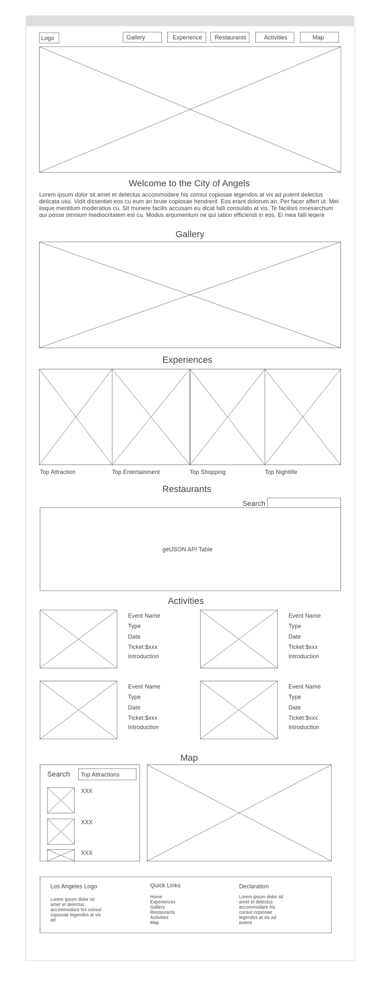Figure 2: Home page

After mapping out all the pages that will be displayed on my site, I drew a wireframe to visualize my website design at the structural level and have a preview of the website. As showed above, the home page will include contents of the whole website. Clicking on menu titles on the navigation bar can directly guide users to the destinated content area. Within the header, users can click the button to see a video of introducing LA to arise their attentions and interests. With smooth page scrolling, a gallery of some gorgeous LA vibe pictures will be presented. And then by keeping scrolling down, users will get to know what some great experiences they can have in LA such as top attractions, top entertainments, top shopping places and top nightlives. By clicking each category, users can enter to a pop-up window to see more content (see figure 3).

Figure 3: Pop-up window

The restaurant part will display some recommended food and drinks on LA through a getJSON table. A search bar will be specially designed for users to find their interested restaurants in a faster way. For the activities page, a display of plentiful fun activities and tours which are popularized among youngsters will be shown. Users can click to view and know more information including pictures, event name, introduction, time, location, price. The map section is designed to show where people can have those top experiences. For example, when users select nightlife experiences, location marks of the recommended nightlife places will be displayed on the map. Finally, a contact section is included at the end of the page for users to send messages by entering contact information first.

**Usability Test**

To evaluate the effectiveness of my website page structure, a usability test was conducted in order to ensure that what I have put together makes sense to users or I may move into visual design. I invited 5 volunteers, among which three are junior college students and 2 are postgraduate students in USA, to answer the following questions:

Q1: What do you think the website is about?

Q2: Is each function clear to you?

Q3: Are there any other functions or contents you expected to see?

According to the test, all volunteers knew the website was some sort of travel guide website and introducing the city of Los Angeles. For the second question, one participants pointed out that the title of “experience” is kind of confusing and better replaced with “things to do” which is intuitive and clear. This reaction inspired me to think deeply of how words can play a factor in navigating user to seek what they want. I adopted this suggestion and was considered made changes to some of the other titles such as “activities” to “find events”. Other participants find each function is pretty clear to them. As for the third question, one suggested to add a page of hotel finding since a trip always started with searching and booking hotels. Another participant recommended to add a function of filtering so that users can filter to find the best results. That participant further explained with examples such as users can filter the activities by price range or type. Although all those suggestions are valuable, they are hard to be realized due to my limited capacity and web development level.

**A/B Test**

Based on the result of usability tests, I created an A/B test experiment in Google Optimization. Not only the test was aimed to see which version performed better, but also to understand how text play an important role on website and whether changing the text will increase clicks, keep users stay longer at the site, and resonate with targeted audiences. I made 2 minor changes with the text. One was changing the title of “experience” in the navigation bar to “things to do”. The other one was replacing “explore the city” button in the header with “explore it now” (see figure 4&5). The user should clearly know what to expect when they click on each button on the site. Since there were participants reported having confusion towards the title of “experience”, I need to take an action to make alternatives and avoid confusion. And the reason why I replaced “explore the city” button with “explore it now” was that the latter was a call-to-action phrase which I believed helps grabbing users’ attention, urging them to act and ultimately getting more conversion.

Figure 4. A/B Testing - A version

Figure 5. A/B Testing - B version

The experiment was run for 10 days from Nov 28th to Dec 7th. Over the ten days testing period, the new variation *(the green line)*, started out performing worse than the original, then outperformed the original, leveled off somewhat, and progressively converged with the original (see figure 6). When looking at the below chart (see figure 6&7), it is clear that the new variation increased average session duration by **3.837%** with an **97%** chance to beat the original. The overall average session duration for the new variation (01:57: 37) was beated the original version (00:08:10). Page views for the new version was increased by **42%**.

Figure 6. A/B Testing result

Figure 7. A/B Testing result

Therefore, the version B has a greater performance than version A in terms of achieving longer average duration session and more page views. Choosing version B apparently is a better choice for achieving the goal of making users view more pages and stay longer at the site.

**Site Performance**

Coming to the last stage of building my website, Google Analytics is an incredibly powerful tool for getting an insight of website performance as well as users who entering the site. It would be very beneficial for me to analyze the website’s performance through key metrics for trends, and then use the information to learn how my website can do more work for targeted users. In order to acquire more traffic for my website, I started to promote it on different channels. I chose Facebook, Instagram, Twitter, WeChat as four main channels since those social media sites are popular and widely used among targeted users. Not only those social media sites helped to reach target users, but also a wider audience. I wrote posts of introducing my website, added the URL on my social media profile and directly referred it to group chats or friends. The promotion was lasted for about 10 days from Nov 28th to Dec 7th.

According to the GA report, there was a total of 50 users were attracted to visit my site, users from China (18) was ranked as the most and followed by Hong Kong (14), United States (10) and Japan (8) (see figure 8&9). Among those users, 88.5% were new visitors and 11.5% were returning users. The overall page views were 187. Visitors visit approximately 3.22 pages per time and typically they spend less than one minute on my website since there were only one page - the page they landed on.

Figure 8. Google Analytics Report

Figure 9. Dashboard

It is worth to mention that users using mobile devices to access the site exceeds users using browsers to do so. It surprised me that the number of sessions using mobile (32) is only slightly higher than the number of sessions using desktop (26). I think the reason can be that I specifically reminded people to better use computer to open my website than using mobile phone when promoting the site. When it comes to browser options, over a half (54.3%) of page visitors utilizing safari. As for traffic sources or medium, WeChat (53.4%) generated the most traffic to my website, and direct referral, Instagram, qq.com, Facebook followed closely. Therefore, promoting through WeChat platform worked more effectively in comparison with other channels. The reason could be WeChat allows to send group messages to large amount of people. However, the makeup of WeChat user base may include people I am not intended to reach such as people who are not identified as international students studied abroad.

**Conclusion**

Based on above, there are several lessons I learned from the whole web design process. First, planning carefully and implementing using a tried-and-tested process is so important to the success of a website project. Clear objectives, defined targeted users, and elaborated user journey map need to be put upfront before designing and web developing. Second, text do matters in web design and it is important to make the text readable and simple. Third, always keeping targeted users in mind when promoting the website. It’s very important to understand when and where the targeted audience is consuming media.

Overall, exploring the world of website design and development in the perspective of design thinking and computational thinking was a unique experience that I am glad I had. I am sure those practical skills and valuable knowledges I acquired along the web development journey will take me to the next level in the future.